Name:___________________________________ Date: __________________

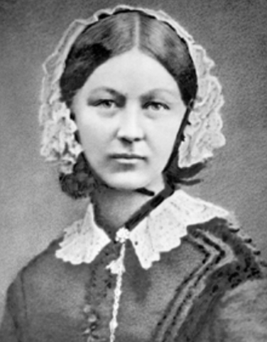
Complete the picture of Florence Nightingale

Florence Nightingale

